VIJAY HYGIENE PRODUCTS
25, STREET No.7-B, ASHOK VIHAR, PH-1, GURGAON (HR)
M: 9350967997, 0124-2200830
Website- www.vijayhygieneproducts.com
Email : info@vijayhygieneproducts.com

1. | Stainless Steel Hand  Dryer 8046C |  | Stainless Steel Body  2300W
2. | Hand Dryer  SC – 2000 | 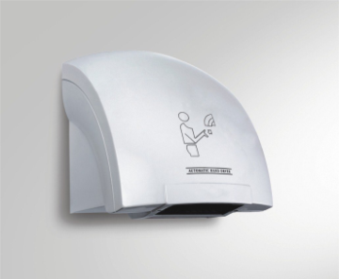 | ABS Body  1800W
3. | Stainless Steel Soap Dispenser 175A |  | Stainless Steel Body  Double Spring Nozzel  500ml
4. | Stainless Steel Soap Dispenser 175C |  | Stainless Steel Body  Double Spring Nozzel  1000ml
5. | Soap Dispenser 1128A | 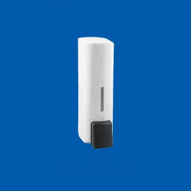 | ABS White colour Body With Black Nozzel  500ml

6. | Soap Dispenser 216A | 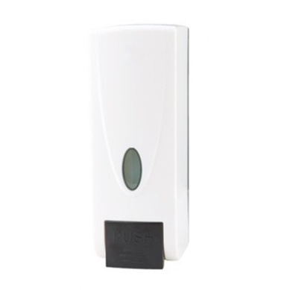 | ABS White colour Body With Black Nozzel  1000ml
7. | Paper Dispenser 528A | 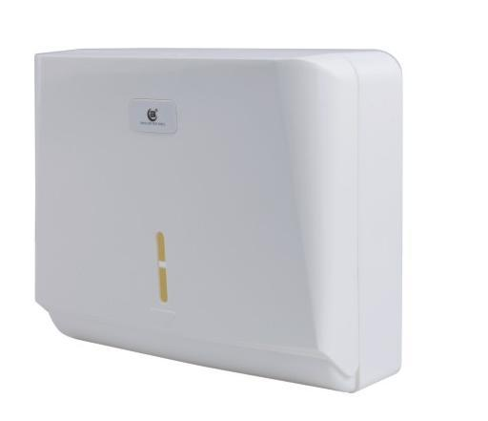 | ABS Body  Off White Colour  For  M-fold & C-Fold Paper
8. | JRT Dispenser 501B |  | ABS Body  Transparent  Blue , Black Colour
9. | Paper Dispenser 512A | 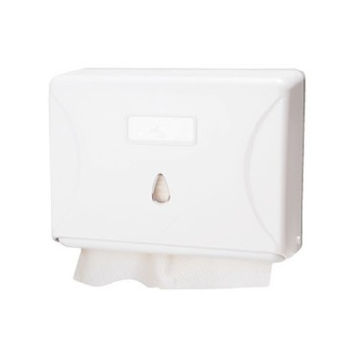 | Plastic Body  White Colour  For  M-fold & C-Fold Paper
10. | Paper Dispenser DJ2001 | 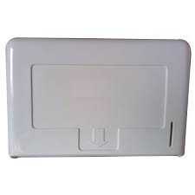 | Plastic Body  White Colour  For  M-fold & C-Fold Paper
11. | Soap Dispenser 001 | 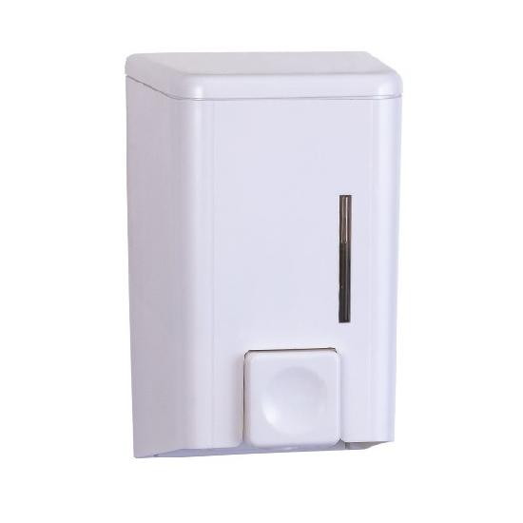 | ABS Body  White Colour  500ml
12. | Soap Dispenser WF-051 | 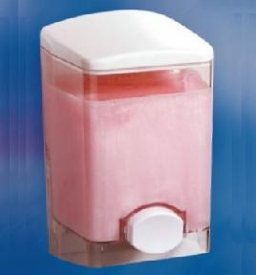 | ABS Body  Transparent  500ml
13. | Soap Dispenser  SD-800 | 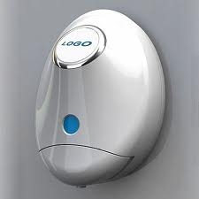 | ABS Body  White Colour  800ml
14. | Foam Soap Dispenser  WF-062 | 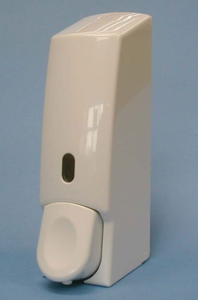 | Foam Soap Dispenser  White Body  500ml

15. | Soap Dispenser  WF-064  WF-065 | 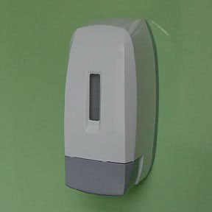 | 500 ml  1000 ml

16. | Soap Dispenser WF-037 | 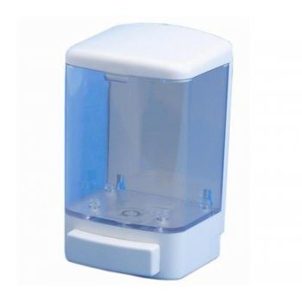 | ABS Body  Transparent  1000ml
17. | Soap Dispenser WF-047A | 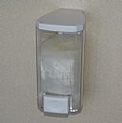 | ABS Body  Transparent  500ml
18. | Soap Dispenser WF-071L | 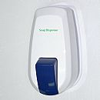 | ABS Body  500ml  GREY Nozzel
19. | Foam Soap Dispenser WF-072 | 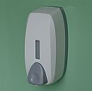 | Foam Soap Dispenser  750ml
20. | Soap Dispenser WF-105 | 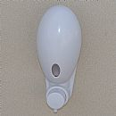 | ABS Body  White Colour  300ml
21. | Soap Dispenser WF-101 | 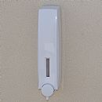 | ABS Body  White Colour  320ml
22. | Automatic Soap dispenser  WF-060A | 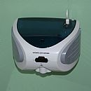 | Touch Free Soap Dispenser  500ml
23. | Automatic Soap dispenser  WF-063 | 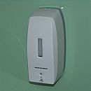 | Touch Free Soap Dispenser  500ml

24. | Paper Dispenser WF-0338 | 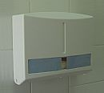 | ABS Body  White Colour  For  M-fold & C-Fold Paper
25. | Paper Dispenser WF-0339 | 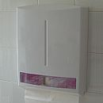 | ABS Body (BIG)  White Colour  For  M-fold & C-Fold Paper
26. | HRT Dispenser WF-0331 | 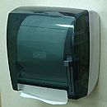 | Hand Roll Towel Dispenser
27. | HRT Dispenser WF-0331W | 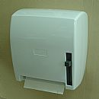 | Hand Roll Towel Dispenser
28. | Automatic  HRT Dispenser WF-0332 | 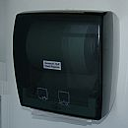 | Sensor Automatic Roll Towel Dispenser
29. | Automatic  HRT Dispenser WF-0332W | 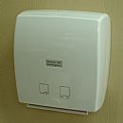 | Sensor Automatic Roll Towel Dispenser

30. | Stainless Steel JRT dispenser  508A
31. | Stainless Steel Tissue Dispenser  518A | 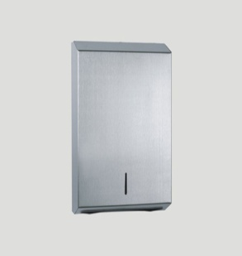
32. | Stainless Steel Tissue Dispenser  518B | 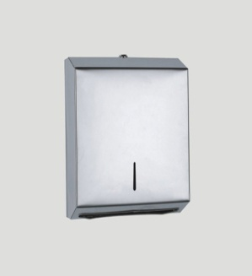
33. | Aroma Diffuser  8001A | 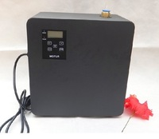 | 180*65*210  mm
34. | Telescopic Pole  6Mtr | 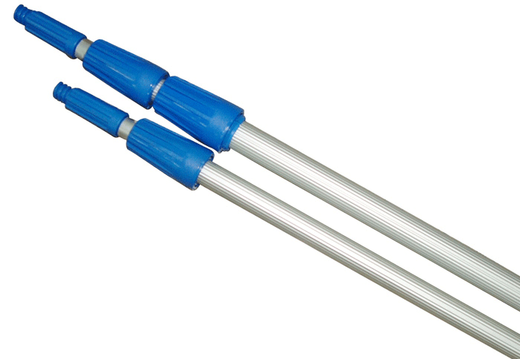 | Heavy Pole

35. | Squeegee 35cm | 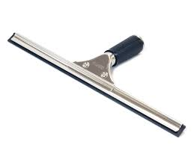
36. | Washer 35cm | 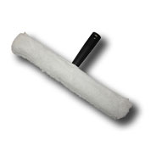
37. | Combi | 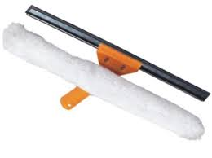
38. | Squeezy Rubber 105cm | 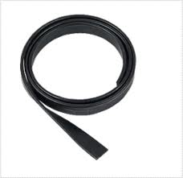
39. | Scrapper Blade  Handle
40. | Scrapper Blade | 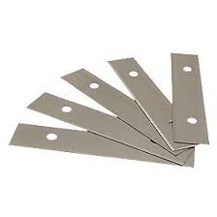

41. | Washer Head | 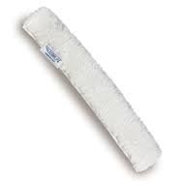
42. | Toilet Deorderer | 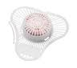
43. | Urinal Screen | 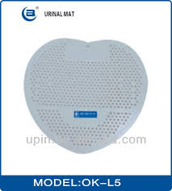
44. | Jet Hand dryer | 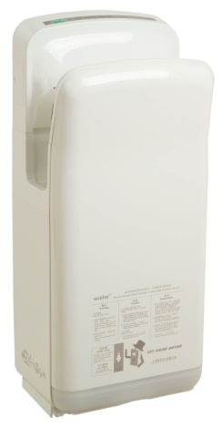

Notes :
1. VAT will be extra as applicable.
2. Freight will be extra as actual. (*Freight includes at the purchase of Rs.30,000/- or above.)
3. Payment terms on delivery.
4. Order will be execute on P.O.(Hard/Soft Copy)
Thanks & Regards,
SUNDEEP SINGH (CEO)
VIJAY HYGIENE PRODUCTS
BUILDING NO.25, STREET NO.7-B,
ASHOK VIHAR, GURGAON (HR).
9350967997, 9811399236
0124-2200830.
www.vijayhygieneproducts.com
info@vijayhygieneproducts.com

